**NNTC Request Processing and Fulfillment Guidelines**

Version 0.77/26 July 2024

Table of Contents

Executive Summary 3

Abbreviations 6

Definitions and Key Terms 6

Process Overview 7

Application Submission 9

a. Create an account 9

b. Ensure that your application is complete and well-justified 9

Application Review 11

a. DCC Review 11

b. NNTC Site PI initial scientific review and local inventory check 12

c. Assignment of Request Complexity Level 12

d. Complexity-driven review timelines 14

e. Examples of feedback you may receive during Application Review 14

f. NIH review of rejected applications 15

g. Revising an application during Application Review 15

Request Fulfillment 16

a. Request fulfillment timelines 16

b. Communicating variance from estimated timelines 16

c. Requestor strategies to optimize request fulfillment timelines 17

Returning Experimental Data to NNTC 19

APPENDIX A: Request Complexity Level Criteria, Application Review, Request Fulfillment Timing 20

APPENDIX B: Standards for provision of NNTC tissues and fluids 23

Executive Summary

The National NeuroHIV Tissue Consortium (NNTC) is dedicated to supporting groundbreaking research in the field of NeuroHIV. Central to our mission is the implementation of a tiered request process designed to optimize efficiency and accelerate the pace of scientific discovery.

At the forefront of this process is the **Level 1 Request Complexity** designation, which represents our commitment to rapid review and fulfillment, ensuring that researchers can swiftly progress from concept to experimentation. Other, more complex, applications can still be accommodated, but timelines for review, approval, and fulfillment are longer (see Overall Request Timelines figure below).

**Key Advantages of Level 1 Requests:**

* **Streamlined Review:** Level 1 requests undergo the fastest review cycle, with a commitment to completing the review process within no more than 15 business days following submission of an application. This expedited pathway significantly reduces wait times, facilitating quicker project initiation.
* **Swift Fulfillment:** Following formal approval, shipments for Level 1 requests will be completed within 25 business days. This efficiency ensures that researchers receive their requested specimens promptly, enabling a seamless transition to the experimental phase of their projects.

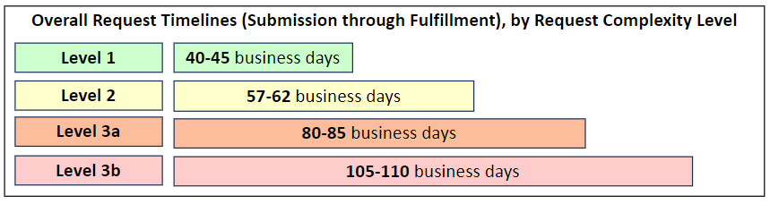

**Encouraging a Strategic Approach *(see criteria, next page):***

We encourage researchers to strategically consider whether their project might align with Level 1 criteria. We strongly encourage researchers to consider pilot or proof-of-concept studies to leverage Level 1 request advantages. This approach not only capitalizes on the efficiency and streamlined nature of Level 1 requests but also serves as a foundational step before scaling up to more extensive research projects. Starting with a pilot or proof-of-concept request that meets Level 1 criteria offers several advantages:

* **Rapid Validation**: Quickly validate feasibility or methodology, providing a solid foundation for larger-scale investigations. In some cases, hypotheses can be addressed.
* **Optimized Resource Use**: Ensure that the research approaches are attainable, optimizing the use of NNTC resources and enabling future project expansions.
* **Informed Scaling**: Gather crucial initial data that can guide the scaling up of research, ensuring that subsequent phases are built on robust, preliminary findings that can also provide guidance for power analyses.

**Level 1 Request Complexity Level Criteria:**

| **Request Complexity**  **Level** | **Request Details** | **Request Complexity Considerations** |
| --- | --- | --- |
| **Level 1** | * A pilot project specimen request (definition on pg7) * A proof-of-concept specimen request (definition on pg7) * A data-only request that includes only centrally maintained data elements. * All requests for Letters of Support will be fulfilled by the NNTC on Level 1 timelines. | *ALL of the following are required for Level 1 specimen requests:*   * ≤12 specimens in total (except for requests for Letters of Support) * Tissue/aliquot amounts at or below standard amounts listed in Appendix B of the NNTC Request Processing and Fulfillment Guidelines document.A * NO small or anatomically limited brain subregions (see below)B * NO complex dissection or custom preparation * Does not require clinical sites to perform microtomy (note – we do not send out blocks of formalin-fixed, paraffin-embedded tissue) |

**Higher Complexity Level Requests:**

The NNTC also fulfills higher complexity level requests. Unlike Level 1 requests, more complex applications have longer review and fulfillment timeframes. Please review the table below for the definitions of higher complexity levels.

| **Request Complexity**  **Level** | **Request Details** | **Request Complexity Considerations** |
| --- | --- | --- |
| **Level 2** | * A specimen request and associated clinical data that meets one or more of the following criteria:   + Demonstrated experience with the proposed technique (e.g., publication or preliminary data)   + History of previous successful use of NNTC specimen resources * A data-only request that requires elements not maintained centrally, and/or requires calculations to be performed, and/or requires specific subject matter expertise. | *ALL of the following is required for Level 2 specimen requests:*   * < 50 specimens in total * Tissue/aliquot amounts at or below standard amounts listed in Appendix B of the NNTC Request Processing and Fulfillment Guidelines document.A * NO small or anatomically limited brain subregions (see below)B * NO complex dissection or custom preparation |
| **Level 3a** | * A specimen request along with associated clinical data that exceeds Level 2 requirements and limits. | *ALL of the following is required for 3a specimen request:*   * Does not exceed 100 specimens totalC * NO small or anatomically limited brain subregions (see below)B * NO complex dissection or custom preparation |
| **Level 3b** | * A specimen request along with associated clinical data that exceeds Levels 2 and 3a requirements and limits. | *ALL of the following are required:*   * Does not exceed 100 specimens in totalC * May require small or anatomically limited brain subregions (see below)B * May require a complex dissection or custom preparation |

*A – If you are requesting tissue/fluid amounts in excess of what is stated in Appendix B for any of the experimental methodologies listed, your application must include specific justification in support of the specimen amount being requested.*

*B - Anatomically limited regions include nucleus accumbens, basal ganglia, hippocampus, striatum, choroid plexus, brain stem nuclei, and any regions or samples that are not part of the required NNTC dissection or are not consistently available or are extremely difficult to find, collect and process from all participants.*

*C - Applications requesting more than 100 total specimens will be evaluated on a case-by-case basis. If approved, the overall request must be broken down into multiple applications (each requesting < 100 specimens) to the NNTC in order to be accommodated.*

**NNTC Request Processing and Fulfillment Guidelines**

Abbreviations

|  |  |
| --- | --- |
| **Abbreviation** | **Description** |
| BD | Business Days |
| CIDI | Composite International Diagnostic Interview |
| CNTN | California NeuroAIDS Tissue Network |
| DCC | Data Coordinating Center |
| EC | Executive Committee |
| FAQ | Frequently Asked Questions |
| FWA | Federalwide Assurance |
| FFPE | Formalin-Fixed Paraffin-Embedded Sections |
| HIV | Human Immunodeficiency Virus |
| MHBB | Manhattan HIV Brain Bank |
| NIH | National Institutes of Health |
| NNAB | National Neurological AIDS Bank |
| NNTC | National NeuroHIV Tissue Consortium |
| PI | Principal Investigator |
| PRISM | Psychiatric Research Interview for Substance and Mental Disorders |
| PWH | People with HIV |
| PWoH | People without HIV |
| SUD | Substance Use Disorder |
| TNRC | Texas NeuroAIDS Research Center |

Definitions and Key Terms

| **Term** | **Description** |
| --- | --- |
| DCC | The Data Coordinating Center (DCC) is responsible for management of the review and approval process for applications. All questions about your request, please contact [nntc@emmes.com](mailto:nntc@emmes.com). |
| Clinical Sites | The NNTC Clinical Sites are the centers that contribute to the NNTC. Clinical Site PIs are the primary reviewers/approvers of NNTC applications, and Clinical Sites are responsible for fulfillment of all NNTC requests. |
| EC | The Executive Committee (EC) is comprised of PIs from each contributing NNTC Clinical Site, CHARTER PIs, and DCC leadership. The EC is responsible for application review and approval. |
| Pilot request | Any request that meets **all** of the following criteria:   * 1-12 total specimens * Does **not** include specimens from anatomically limited regions (e.g., nucleus accumbens) * Does **not** include specimens that require complex dissection or special preparation (e.g., microtomy) |
| Proof-of-Concept request | Any request that meets **all** of the following criteria:   * 1-12 total specimens * Includes scientific methodology that requires validation using NNTC specimens before proceeding to a larger scale request. * Does **not** include specimens from anatomically limited regions (e.g., nucleus accumbens) * Does **not** include specimens that require complex dissection or special preparation (e.g., microtomy) |
| Specimen | A quantity of tissue, blood, or other biologically derived material. |
| Donor | An individual person who has donated specimens to the NNTC. |

Process Overview

**Key Takeaways – Process Overview:**

This section provides an overview of the review, approval, and fulfillment process for NNTC applications, from submission through request fulfillment. The process consists of the following steps:

1. Application Submission
2. Application Review
3. Request Fulfillment

Once you have submitted a complete application to the NNTC, your application will enter the review and approval process. To be considered approved, a new NNTC application must navigate all elements of the review process, as described below:

**Figure 1**: NNTC Request Process Overview

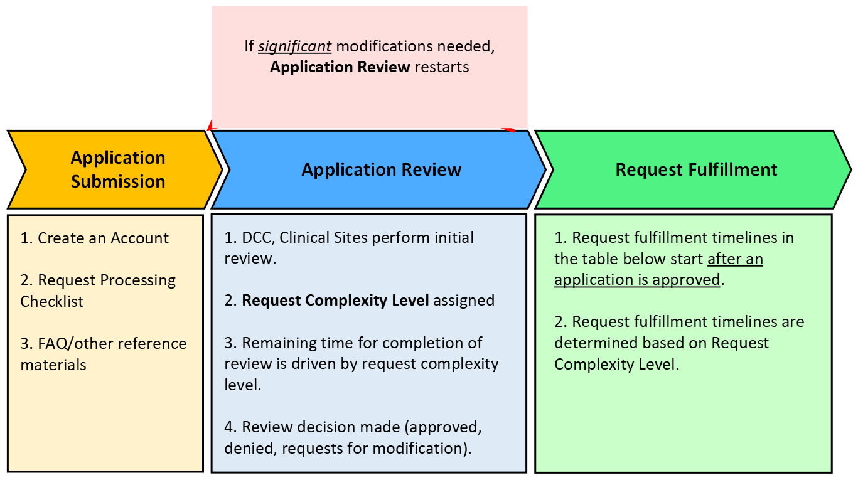

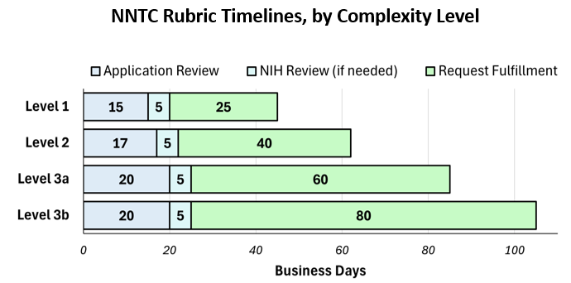

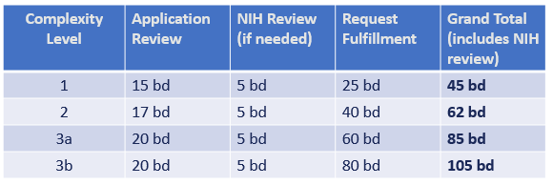

Note: The NNTC aims to fulfill sample requests according to the timelines outlined in this figure. These timelines are based on ideal conditions. However, real-world conditions may affect actual fulfillment timelines (e.g., length of existing request queue). See the Request fulfillment section for further information.

Please note that all requests submitted to the NNTC are processed by the Data and Coordinating Center (DCC) in the order in which they are received. This document outlines the process for how applications to the NNTC will be processed following submission. If you have questions prior to submitting your request, please do not hesitate to contact [nntc@emmes.com](mailto:nntc@emmes.com) to reach the DCC.

Application Submission

**Key Takeaways –Application Submission:**

A complete and well-thought-out application is the **best way** to avoid additional time being required for review/approval of your application. In this section, we offer the following suggestions:

* Use the **Request Processing Checklist**.
* In addition to the Request Processing Checklist, review the Concept Outline template for guidance about the information and level of detail needed in your application to ensure that your request is clear and complete.
* If an application requires *significant* modification at any time, the application will return to the start of Application Review.

The first step in the NNTC application review and fulfillment process is submission of the application itself. This step is critical for determining request review and fulfillment timelines.

## Create an account

New Users: If you do not already have an account with the NNTC, you must submit a request for credentials via the study website ([www.nntc.org](http://www.nntc.org)). The DCC will create your credentials within 2 business days.

Existing Users: Use your DCC-provided credentials to [log in](https://nntc.org/user/login?current=node/1) to the secure portion of the study website to begin your application submission process.

## Ensure that your application is complete and well-justified

Use a **copy of the Request Processing Checklist as you compile your application to ensure that your request is clear, complete, and well-justified**. To document that you reviewed, understood, and followed the checklist, you must submit a **signed** copy of the Request Processing Checklist as part of any application.

Requestors **must submit applications that are well-justified and include sufficient details to support the specimens requested in your application** (e.g., study group sizes, number of specimens being requested, rationale, study design, experimental methodologies, etc…). The Request Processing Checklist and Concept Outline templates are helpful resources in this regard. In addition, please consult the Request FAQ document available on the study website.

The NNTC Project Outline document required for all applications includes the main components of rationale, justification needed for any given application. Please see the table below for details:

| **Category** | **Description** |
| --- | --- |
| Background Research: | Briefly describe prior research that highlights the importance of the proposed research topic. |
| Major Goals of the Research: | Describe the major goals of the research. List specific aims and hypotheses and how these relate to the research questions. |
| Analysis Variables: | List analysis variables: outcome dependent variables, independent variables of primary interest, and other variables to control in the analysis. |
| Experimental Methodology: | For all specimen types/preparations requested in your application, outline your experimental design and methods for the research. Include sufficient information and detail to enable reviewers to evaluate the specific parameters associated with your request (e.g., brain region, specific techniques to be used, specimen weight/size, number of sections, section thickness). This portion of your concept outline should not exceed one page. |
| Statistical Methods/Approaches: | Describe the statistical approach and methods anticipated for the research. If requesting specimens, justify the number required via power calculations if the number requested is large, or defend precision of the resulting study estimates if the number is low. |
| Feasibility: | Insert a paragraph indicating whether the specimen/data analysis methods are already established or will have to be developed (and if so, the timeframe to test the system). It is important to convey a timeline for completion of the work. |
| Justification: | Justify the specific specimen types and amounts you are requesting. If this is a data only request, justify the types of data you are requesting. |

Application Review

**Key Takeaways – Application Review:**

This section outlines the steps involved in the Application Review process for a specimen/data/analysis application to the NNTC. The basic process for this step of review is as follows:

1. DCC, Clinical Site review of application to assess complexity, feasibility – 10 bd
2. Assignment of Request Complexity Level (defines duration of remaining review)
3. Sites complete review, make requests for modification, or render approval/denial decision.
4. If an application is rejected by the NNTC EC, the NIH will perform a review of the application and Site PI reviews and make a decision about the application that will supersede the decision made by the EC.

As the investigator filing an application with the NNTC, the NNTC emphasizes the following from this section:

* NNTC expects requesters to respond to any NNTC communications within 2 bd. Delays in responsiveness will impact the review timeline.
* An application that requires significant modification will return to the beginning of Application Review and the overall timeline will restart.

The DCC and Clinical Sites will perform an Application Review of each application to ensure it is complete and scientifically justified before assigning a request complexity level and following up with an in-depth evaluation of the request.

To ensure timely completion of Application Review, applicants should try to answer any questions from the DCC within **2 business days**. Delays in responding will add time to the review of your application.

## DCC Review

First, the DCC reviews the application to verify that all required elements of the application package have been provided and are complete. The DCC then sends the application to Site PIs for their initial scientific review and Site inventory check.

*Note: Please see the Request Processing Checklist for a comprehensive checklist detailing the materials/information that comprise a complete and clear application to the NNTC.*

## NNTC Site PI initial scientific review and local inventory check

Once the DCC completes its initial review, the NNTC Site PIs will also review your application to determine whether 1) their Site has donors/specimens that match the scientific needs of the request, and 2) they have questions /issues that need to be resolved before evaluating the feasibility of the request.

The application is then screened by all of the NNTC Site PIs (TNRC, CNTN, NNAB, and MHBB) with a focus on scientific content and feasibility. There may then be a communication sent back to you to answer any questions and/or requests for clarification including those regarding feasibility or rationale. All questions must be adequately addressed before your request moves to the next step in the approval process. NNTC expects that requestors will respond to inquiries relating to their request within 2 business days of receipt.

In addition, the site PIs and/or their data managers will perform a preliminary assessment of specimen availability for those donors/specimens included in your application. Please note that there are some instances where formal verification of inventory is not feasible prior to the fulfillment step of the NNTC application review process. For example, if a subregion of the hippocampus is requested, NNTC Clinical Sites would be able to determine donors that have hippocampus available but would not be able to confirm the presence of subregions until the time donor tissue is pulled for dissection.

## Assignment of Request Complexity Level

After the initial review and local inventory check, a “**Request Complexity Level**” is assigned. The complexity level is determined by request size, complexity, and other factors (see the table below for further detail). The Request Complexity Level guides the timelines for the remaining request review and fulfillment processes. Once your application has been assigned a Request Complexity Level, your application will continue through remaining review by the NNTC Executive Committee (EC).

Please see Appendix A for a full table including Request Complexity Level criteria and the associated timelines for the remaining Review and Request Fulfillment processes.

Request Complexity Level is determined according to the criteria in the below table:

| **Request Complexity**  **Level** | **Request Details** | **Request Complexity Considerations** |
| --- | --- | --- |
| **Level 1** | * A pilot project specimen request (see definition, pg7) * A proof-of-concept specimen request (see definition, pg7) * A data-only request that includes only centrally maintained data elements. * All requests for Letters of Support will be fulfilled by the NNTC on Level 1 timelines. | *ALL of the following are required for Level 1 specimen requests:*   * ≤12 specimens in total (except for requests for Letters of Support) * Tissue/aliquot amounts at or below standard amounts listed in Appendix B of the NNTC Request Processing and Fulfillment Guidelines document.A * NO small or anatomically limited brain subregionsB * NO complex dissection or custom preparation * Does not require clinical sites to perform microtomy (note – we do not send out blocks of formalin-fixed, paraffin-embedded tissue) |
| **Level 2** | * A specimen request and associated clinical data that meets one or more of the following criteria:   + Demonstrated experience with the proposed technique (e.g., publication or preliminary data)   + History of previous successful use of NNTC specimen resources * A data-only request that requires elements not maintained centrally, and/or requires calculations to be performed, and/or requires specific subject matter expertise. | *ALL of the following is required for Level 2 specimen requests:*   * < 50 specimens in total * Tissue/aliquot amounts at or below standard amounts listed in Appendix B of the NNTC Request Processing and Fulfillment Guidelines document.A * NO small or anatomically limited brain subregionsB * NO complex dissection or custom preparation |
| **Level 3a** | * A specimen request along with associated clinical data that exceeds Level 2 requirements and limits. | *ALL of the following is required for 3a specimen request:*   * Does not exceed 100 specimens totalC * NO small or anatomically limited brain subregionsB * NO complex dissection or custom preparation |
| **Level 3b** | * A specimen request along with associated clinical data that exceeds Levels 2 and 3a requirements and limits. | *ALL of the following are required:*   * Does not exceed 100 specimens in totalC * May require small or anatomically limited brain subregionsB * May require a complex dissection or custom preparation |

*A – If you are requesting tissue/fluid amounts in excess of what is stated in Appendix B for any of the experimental methodologies listed, your application must include specific justification in support of the specimen amount being requested.*

*B - Anatomically limited regions include nucleus accumbens, basal ganglia, hippocampus, striatum, choroid plexus, brain stem nuclei, and any regions or samples that are not part of the required NNTC dissection or are not consistently available or are extremely difficult to find, collect and process from all participants.*

*C - Applications requesting more than 100 total specimens will be evaluated on a case-by-case basis. If approved, the overall request must be broken down into multiple applications (each requesting < 100 specimens) to the NNTC in order to be accommodated.*

## Complexity-driven review timelines

Once Request Complexity Level is assigned, the application will be more comprehensively reviewed by the NNTC Executive Committee. Application review times are determined by a given application’s assigned Request Complexity Level. **Remaining** **review timelines** **Appendix A** **start after Request Complexity Level is assigned.**

## Examples of feedback you may receive during Application Review

Over the course of Application Review, you may receive feedback regarding your application. Examples include, but are not limited to:

* *Technical*:
  + There are concerns regarding the feasibility of using the specimen preparations requested with specific laboratory methodologies in the request.
  + The particular methodology you plan may not be viable using the specimens you requested. The EC may ask you to revise and resubmit your application as a proof-of-concept request.
* *Clarification*:
  + The EC may ask questions about any element of your request that may not seem consistent with the rest of your application. For example, if you submit a request focused on the use of cardiac specimens and your group definitions include neurocognitive inclusion/exclusion criteria, you will be asked to explain how the neurocognitive criteria are relevant to your application.
  + You may be asked to consider alternate brain regions for your request if the regions requested are not adequately justified, or are in short supply, or require extensive preparation or dissection.

## NIH review of rejected applications

If an application is rejected by the EC during Application Review, representatives from the NIH will review the application and EC review. NIH staff will consult with the EC, DCC, and applicant during this review process. NIH staff will then make a final decision regarding the application. This NIH review will occur within 5 business days following any rejection decision from the EC.

## Revising an application during Application Review

Requesters should anticipate that their request may require some modification or clarification during Application Review. If your application requires modification, the NNTC will determine whether the modifications required are “significant” or “minor”. In all cases, the requester *must* accommodate all requested modifications.

If your application requires *significant* modifications, your modified (or new) application will go back to the beginning of the Application Review step and will re-enter the review process once the revised application is submitted.

If only *minor* modifications are required, your application will be considered approved *once you have addressed all modifications requested.* Applications requiring only minor modifications will *not* return to the beginning of the Application Review step.

The NNTC DCC is available to assist you with your application. If you have questions regarding request feasibility, scientific rationale, and/or complexity when preparing your application or during Application Review, you may request guidance from the DCC and/or Clinical Sites. The DCC can be reached during normal business hours at [nntc@emmes.com](mailto:nntc@emmes.com). If you contact the DCC outside of business hours, someone from the DCC will get back to you within 2 business days.

Request Fulfillment

**Key Takeaways – Request Fulfillment:**

This section outlines the steps involved in the Request Fulfillment step for an NNTC request. Highlights from this section include:

* Request fulfillment timelines are determined by the application Request Complexity Level.
* Deviations from the estimated timelines may occur based on several factors (e.g., fulfillment queue), as outlined in this document. The DCC will communicate transparently with requesters when fulfillment timelines may require additional time. The DCC provides a dashboard summary on the study website to provide investigators insight into pertinent factors that may affect shipment timelines.

This section includes recommendations for optimizing request fulfillment timelines. NNTC emphasizes the following:

* Minimize request complexity
* Specify staging for request fulfillment
* Consult resources on the NNTC study website (FAQ, Request Processing Checklist) prior to submitting an application.

## Request fulfillment timelines

Once an application has been approved during Application Review, request fulfillment begins. Application fulfillment times are driven by a given application’s assigned Request Complexity Level. **Request fulfillment timelines in** **Appendix A** **start after an application is approved in the Application Review step.**

## Communicating variance from estimated timelines

The NNTC aims to fulfill sample requests according to the timelines outlined in Appendix A. These timelines are based on ideal conditions; however, real-world conditions may affect actual fulfillment timelines. Examples of such factors include, but are not limited to:

* Length of existing request queue (i.e., the number and complexity of previously approved requests that are in the process of fulfillment).
* Site demand and capacity for request fulfillment (e.g., local personnel are out on vacation, out sick, fulfilling multiple complex requests)
* Requirement for non-NNTC services to process samples (e.g., your sample requires sectioning by an external microtomy lab)
* Some Clinical Site pathologists may have clinical workloads that could introduce some delays in fulfillment timelines (e.g., pathologists may need to accommodate clinical responsibilities such as processing of tumors, surgical specimens, etc. that would take priority over fulfillment of NNTC requests.

The NNTC prioritizes open and transparent communication about deviations from the request fulfillment timelines provided in Appendix A. To this end, the NNTC DCC provides a real-time summary on the study website that summarized the current request workload for each of the four NNTC Clinical Sites (e.g., number of current requests being fulfilled, number and complexity of specimens in queue to ship).

## Requestor strategies to optimize request fulfillment timelines

There are a few ways to optimize your application’s review and fulfillment timelines.

* + 1. Minimize request complexity

Applications with a lower Request Complexity Level are subject to notably quicker review and fulfilment timelines. As such, there is an operational advantage to designing a request to minimize parameters relevant to Request Complexity Level determination (e.g., number of donors, number of specimen/preparation types, etc…).

* + 1. Specify staging for request fulfillment

To help avoid any timing concerns for receipt of specimens, the NNTC advises that all investigators carefully consider how specimen provision might be staged, such that critical specimens are received first, with any remaining specimens to be provided at a later date. These details will be important to include in the details of your application. The NNTC encourages investigators to contact the DCC at [nntc@emmes.com](mailto:nntc@emmes.com) with any questions about how to best incorporate this into an application.

* + 1. Fully justify the inclusion of any virally suppressed donors.

Any request that includes suppressed donors will require more rigorous review by the Executive Committee, because of the scarcity of such donors in the NNTC cohort. If suppressed donors are not essential for the conduct of your research, the NNTC recommends you carefully consider whether this can be removed as a criterion included in your request.

* + 1. Fully justify the inclusion of any small or anatomically scarce regions.

Any request that includes a request anatomically scarce regions will require more rigorous review by the EC, due to the scarcity of such specimens in the NNTC cohort. If anatomically scarce regions are not essential for the conduct of your research, the NNTC recommends you carefully consider whether this can be removed as a requirement of your request.

* + 1. Consult resources on the NNTC study website

Consult the FAQ and related resources provided by the DCC on the study website for further suggestions/information.

* + 1. Include power calculations to justify group sizes for all requests, except Level 1 pilot/proof of concept studies

The NNTC reviews all applications to ensure that appropriate statistical justification (i.e., power calculations) are provided in support of group size(s), number of specimens being requested in any given application. If this is absent, or lacking, your application may be returned to you for modification.

Returning Experimental Data to NNTC

All requestors *must* return any experimental data generated from specimens obtained from the NNTC. The NNTC Data Coordinating Center (DCC) coordinates, stores, and makes accessible all de-identified data obtained from the NNTC subjects and specimens derived from the subjects. All requestors agree to the following when signing the NNTC User Agreements, a required component of all applications:

* The NIH expects NNTC recipients to provide the DCC with electronic copies of all data within twelve (12) months of receiving the materials or within a month of publication of data using samples from NNTC, following an update at 12 months.
* Continued reporting to the DCC should occur at least annually as the analysis progresses until the analysis is completed.
* Data can be embargoed to prevent its release until publication. All data will be referenced to the investigator and publication when relevant.
* For indexing purposes, the NNTC expects recipients to submit data in a specific format with an NNTC subject ID number; forms for this submission will be provided upon approval of the resource request.
* Data will be provided to the NNTC DCC in a format to be determined in conjunction with the DCC depending on the type of data. The DCC will provide templates and examples to the requestor upon approval of the request, followed by annual reminders.
* High-throughput data (genomic, gene expression, protein and metabolomics data) should be submitted to the appropriate NCBI repository (dbGap { <https://www.ncbi.nlm.nih.gov/gap/>} for genomic, GEO {<https://www.ncbi.nlm.nih.gov/geo/>} for gene expression, other data types if/as they become available), using their respective formats and the appropriate links provided to the DCC. Other high-throughput as well as medium- and low-throughput datasets and associated metadata are to be submitted to the DCC; working with the DCC to determine the best format to transfer data.

**Important:** Following receipt of NNTC specimens for any given request, all requestors *must* submit an annual progress report(s) to the DCC from prior requests (including a description of data obtained and a timeline for completion of the project), and experimental data from any completed projects, *before* any additional applications to the NNTC will be processed.

APPENDIX A: Request Complexity Level Criteria, Application Review, Request Fulfillment Timing

| **Request Complexity Level** | **Request Details** | **Request Complexity Considerations** | **Review Period** | **Request Fulfillment** |
| --- | --- | --- | --- | --- |
| **Level 1** | * A pilot project specimen request (see definition) * A proof-of-concept specimen request (see definition) * A data-only request that includes only centrally maintained data elements. * All requests for Letters of Support will be fulfilled by the NNTC on Level 1 timelines. | *ALL of the following are required for Level 1 specimen requests:*   * ≤12 specimens in total (except for requests for Letters of Support) * Tissue/aliquot amounts at or below standard amounts listed in Appendix B,A * NO small or anatomically limited brain subregionsB * NO complex dissection or custom preparation * Does not require clinical sites to perform microtomy | No more than **5 business days** after Request Complexity Level is assigned. | * Shipments begin within **15 business days of application approval**. * Shipments complete within **25 business days of application approval**. |
| **Level 2** | * A specimen request and associated clinical data that meets one or more of the following criteria:   + Demonstrated experience with the proposed technique (e.g., publication or preliminary data)   + History of previous successful use of NNTC specimen resources * A data-only request that requires elements not maintained centrally, and/or requires calculations to be performed, and/or requires specific subject matter expertise. | *ALL of the following is required for Level 2 specimen requests:*   * < 50 specimens total * Tissue/aliquot amounts that are less than or equal to standard amounts listed in Appendix B,A * NO small or anatomically limited brain subregionsB * NO complex dissection or custom preparation | No more than **7 business days** after Request Complexity Level is assigned. | * Shipments begin within **25 business days of application approval.** * Shipments complete within **40 business days of application approval**. |
| **Level 3a** | * A specimen request along with associated clinical data that exceeds Level 2 requirements and limits. | *ALL of the following is required for 3a specimen request:*   * Does not exceed 100 specimens totalC * NO small or anatomically limited brain subregionsB * NO complex dissection or custom preparation | No more than **10 business days** after Request Complexity Level is assigned. | * Shipments begin within **45 business days of application approval.** * Shipments complete within **60 business days of application approval**. |
| **Level 3b** | * A specimen request along with associated clinical data that exceeds Levels 2 and 3a requirements and limits. | *ALL of the following are required:*   * Does not exceed 100 specimens in totalC * May require small or anatomically limited brain subregionsB, * May require a complex dissection or custom preparation | No more than **5 business days** after Request Complexity Level is assigned. | * Shipments begin within **65 business days of application approval**. * Shipments complete within **80 business days of application approval**. |

*A – If you are requesting tissue/fluid amounts in excess of what is stated in Appendix B for any of the experimental methodologies listed, your application must include specific justification in support of the specimen amount being requested.*

*B - Anatomically-limited regions Include (nucleus accumbens, basal ganglia, hippocampus, striatum, choroid plexus, brain stem nuclei, and any regions or samples that are not part of the required NNTC dissection or are not consistently available or are extremely difficult to find, collect and process from all participants.)*

*C - Applications requesting more than 100 total specimens will need to be evaluated on a case-by-case basis. If approved, the overall request must be broken down into multiple applications (each requesting < 100 specimens) to the NNTC in order to be accommodated.*

APPENDIX B: Standards for provision of NNTC tissues and fluids

| **Method** | **Standards, by Method** |
| --- | --- |
| Immunoblot | ≤ 100 mg of tissue per protein examined |
| Mass Spectrometry | 50-100 mg |
| qPCR | ≤ 50 mg |
| High-throughput sequencing | ≤ 50 mg |
| Spatial transcriptomics | Dependent on procedure used |
| Assays on frozen tissue blocks (e.g., laser capture microdissection, immunofluorescence) | 500 mg (1 cm x 1 cm x 0.5 cm) |
| Assays on FFPE (e.g., *in situ* hybridization, immunohistochemistry) | Sufficient tissue for ≤ 6 sections per condition  Standard section thickness is 4-6 µm. |
| **Specimen/Tissue type** | **Standard Preparation, Volume Standards** |
| PBMCs | * 5 x 106 cells * Available frozen as **non-cryopreserved (non-viable) only** |
| * Plasma * Serum * CSF * Urine | * 0.5 ml aliquot |