**Executive Summary**

The National NeuroHIV Tissue Consortium (NNTC) is dedicated to supporting groundbreaking research in the field of NeuroHIV. Central to our mission is the implementation of a tiered request process designed to optimize efficiency and accelerate the pace of scientific discovery.

At the forefront of this process is the **Level 1 Request Complexity** designation, which represents our commitment to rapid review and fulfillment, ensuring that researchers can swiftly progress from concept to experimentation. Other, more complex, applications can still be accommodated, but timelines for review, approval, and fulfillment are longer (see Overall Request Timelines figure below).

**Key Advantages of Level 1 Requests:**

* **Streamlined Review:** Level 1 requests undergo the fastest review cycle, with a commitment to completing the review process within no more than 15 business days following submission of an application. This expedited pathway significantly reduces wait times, facilitating quicker project initiation.
* **Swift Fulfillment:** Following formal approval, shipments for Level 1 requests will be completed within 25 business days. This efficiency ensures that researchers receive their requested specimens promptly, enabling a seamless transition to the experimental phase of their projects.

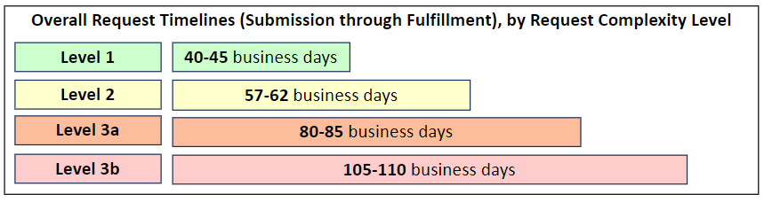

**Encouraging a Strategic Approach (see criteria below):**

We encourage researchers to strategically consider whether their project might align with Level 1 criteria. We strongly encourage researchers to consider pilot or proof-of-concept studies to leverage Level 1 request advantages. This approach not only capitalizes on the efficiency and streamlined nature of Level 1 requests but also serves as a foundational step before scaling up to more extensive research projects. Starting with a pilot or proof-of-concept request that meets Level 1 criteria offers several advantages:

* **Rapid Validation**: Quickly validate feasibility or methodology, providing a solid foundation for larger-scale investigations. In some cases, hypotheses can be addressed.
* **Optimized Resource Use**: Ensure that the research approaches are attainable, optimizing the use of NNTC resources and enabling future project expansions.
* **Informed Scaling**: Gather crucial initial data that can guide the scaling up of research, ensuring that subsequent phases are built on robust, preliminary findings that can also provide guidance for power analyses.

**Level 1 Request Complexity Level Criteria:**

| **Request Complexity**  **Level** | **Request Details** | **Request Complexity Considerations** |
| --- | --- | --- |
| **Level 1** | * A pilot project specimen request (definition below) * A proof-of-concept specimen request (definition below) * A data-only request that includes only centrally maintained data elements. * All requests for Letters of Support will be fulfilled by the NNTC on Level 1 timelines. | *ALL of the following are required for Level 1 specimen requests:*   * ≤12 specimens in total (except for requests for Letters of Support) * Tissue/aliquot amounts at or below standard amounts listed in Appendix B of the NNTC Request Processing and Fulfillment Guidelines document.A * NO small or anatomically limited brain subregionsB * NO complex dissection or custom preparation * Does not require clinical sites to perform microtomy (note – we do not send out blocks of formalin-fixed, paraffin-embedded tissue) |

**Higher Complexity Level Requests:**

The NNTC also fulfills higher complexity level requests. Unlike Level 1 requests, more complex applications have longer review and fulfillment timeframes. Please review the table below for the definitions of higher complexity levels.

| **Request Complexity**  **Level** | **Request Details** | **Request Complexity Considerations** |
| --- | --- | --- |
| **Level 2** | * A specimen request and associated clinical data that meets one or more of the following criteria:   + Demonstrated experience with the proposed technique (e.g., publication or preliminary data)   + History of previous successful use of NNTC specimen resources * A data-only request that requires elements not maintained centrally, and/or requires calculations to be performed, and/or requires specific subject matter expertise. | *ALL of the following is required for Level 2 specimen requests:*   * < 50 specimens in total * Tissue/aliquot amounts at or below standard amounts listed in Appendix B of the NNTC Request Processing and Fulfillment Guidelines document.A * NO small or anatomically limited brain subregionsB * NO complex dissection or custom preparation |
| **Level 3a** | * A specimen request along with associated clinical data that exceeds Level 2 requirements and limits. | *ALL of the following is required for 3a specimen request:*   * Does not exceed 100 specimens totalC * NO small or anatomically limited brain subregionsB * NO complex dissection or custom preparation |
| **Level 3b** | * A specimen request along with associated clinical data that exceeds Levels 2 and 3a requirements and limits. | *ALL of the following are required:*   * Does not exceed 100 specimens in totalC * May require small or anatomically limited brain subregionsB * May require a complex dissection or custom preparation |

*A – If you are requesting tissue/fluid amounts in excess of what is stated in Appendix B* of the NNTC Request Processing and Fulfillment Guidelines document *for any of the experimental methodologies listed, your application must include specific justification in support of the specimen amount being requested.*

*B - Anatomically limited regions include nucleus accumbens, basal ganglia, hippocampus, striatum, choroid plexus, brain stem nuclei, and any regions or samples that are not part of the required NNTC dissection or are not consistently available or are extremely difficult to find, collect and process from all participants.*

*C - Applications requesting more than 100 total specimens will be evaluated on a case-by-case basis. If approved, the overall request must be broken down into multiple applications (each requesting < 100 specimens) to the NNTC in order to be accommodated.*

**Definitions and Key Terms:**

| **Term** | **Description** |
| --- | --- |
| Pilot request | Any request that meets **all** of the following criteria:   * 1-12 total specimens * Does **not** include specimens from anatomically limited regions (e.g., nucleus accumbens) * Does **not** include specimens that require complex dissection or special preparation (e.g., microtomy) |
| Proof-of-Concept request | Any request that meets **all** of the following criteria:   * 1-12 total specimens * Includes scientific methodology that requires validation using NNTC specimens before proceeding to a larger scale request. * Does **not** include specimens from anatomically limited regions (e.g., nucleus accumbens) * Does **not** include specimens that require complex dissection or special preparation (e.g., microtomy) |
| Specimen | A quantity of tissue, blood, or other biologically derived material. |